We can run multiple TESTS of testing parallel. We can run **class**, **test**, and **method** parallelly.

**1. Class parallel execution :** We have set parameter parallel = class, so it executes the classes parallel.

<suite name=*"My suit"* parallel=*"classes"*> <!-- THIS IS PARRELEL EXECUTION OF TESTS -->

<test name=*"My name"*>

<!-- <classes> <class name="p1.Test1" /> <methods> <include name = "m2"/>

//execute m2 from test1 <include name = "m3"/> //execute m3 from test1 </methods>

<class name="p1.Test2"> </class> // end here too </classes> -->

<packages>

<package name=*"p1"* />

<classes>

<class name=*"p1.Test1"* />

<class name=*"p1.Test2"* />

<!-- IT WILL EXECUTE ABOVE MENTIONED 2 CLASSES PARALLELY -->

<!-- <groups> <run> <include name="Regression" /> <include name="Sanity"

/> </run> </groups> -->

</classes>

</packages>

</test>

</suite>

**2. Methods parallel execution** : Here it runs methods parallelly

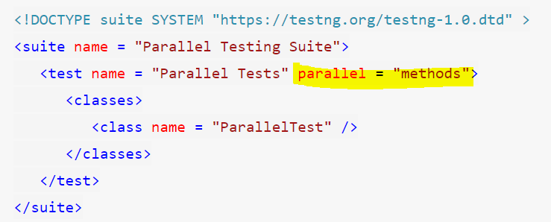

**Threads** in parallel testing refer to different parts in which the test execution will be divided and run parallelly. So if there are two threads and two methods, they will take one method each and run them parallelly (if we are running the **methods** parallelly). But if there are three methods and two threads, one will have to wait until one thread is free and takes up that method for execution. Therefore, we need to specify the number of threads we want to run while performing parallel testing in TestNG. ***The TestNG has a default value of thread = 5 for parallel testing***. It is ok even if we do not mention thread for parallel testing always.

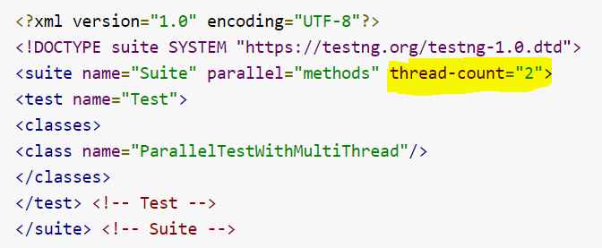

3. **Test parallel execution** : Here it runs tests parallelly

